Loan Calculator

React Interview Question By [RoadsideCoder](https://www.youtube.com/c/roadsidecoder)

Watch the Video Solution - [React JS Interview Questions ( EMI Calculator ) - Frontend Machine Coding Interview Experience](https://www.youtube.com/watch?v=YvgUeUlpwyA)

This EMI calculator shall display the loan EMIs on a car or home loan with a down Payment ( if any ).

This can be used while Investing, Insurance, House, Car, or anything.

For example, you want to buy a house for Rs 50,00,000. You would make a down payment of 20% or Rs 50,00,000 * 0.2 = Rs 10,00,000.

The bank would sanction the home loan of Rs 40,00,000. You have processing fees of 1% of the loan amount or Rs 40,00,000 * 0.01 = Rs 40,000.

The total amount you need for the down payment is Rs 10,00,000 + Rs 40,000 = Rs 10,40,000.

**Total down payment = Rs 10.4 lakh.**

EMI amount = [P x R x (1+R)^N]/[(1+R)^N-1] where P, R, and N are the variables.

This also means that the EMI value will change every time you change any of the three variables.

**‘P’ stands for the Principal Amount**. It is the original loan amount given to you by the bank on which the interest will be calculated.

**‘R’ stands for the Rate of Interest** set by the bank.

**‘N’ is the Number of Years** given to you for loan repayment.

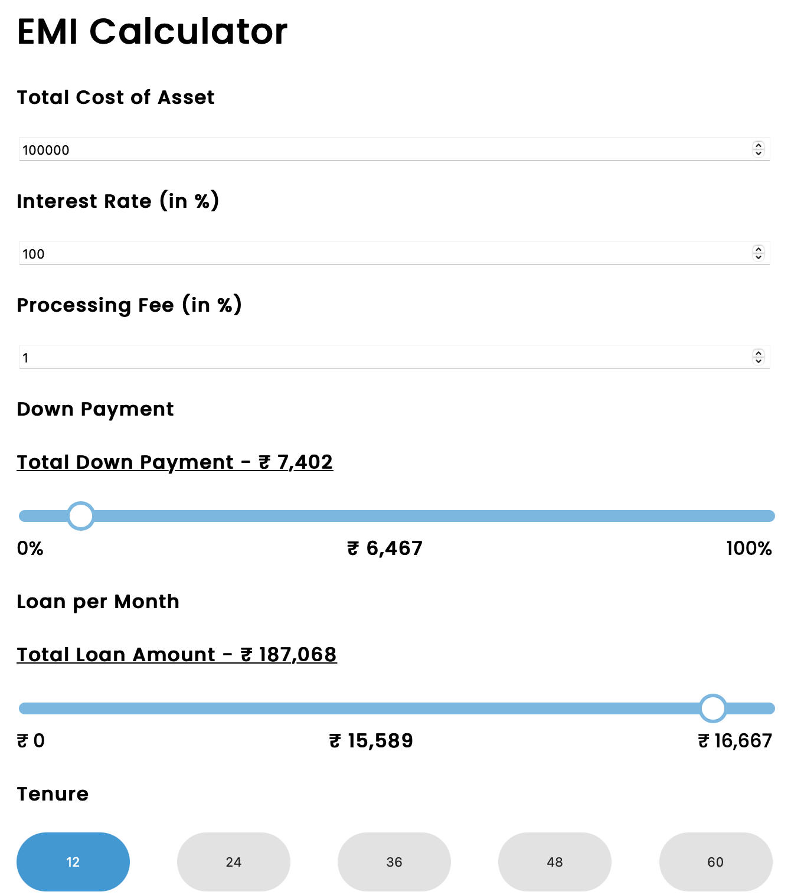

## Coding Practices

* Modular Structure with reusable components
* Proper formatting for Currencies values
* Validation of Interest rate and Processing fee % (should not increase more than 100)